**Evidence Manager Manual**

Table of Contents

Starting the program. 3

Login as a user. 4

Accessing quick help. 5

Searching/viewing evidence data. 6

Login as an administrator. 7

Searching/viewing evidence data as administrator. 8

Adding new evidence data. 9

Editing existing evidence data. 10

Removing existing evidence data. 11

**Evidence Manager User Manual**

# Starting the program.

Start the server by double-clicking server.jar file.



Start the client by double-clicking client.jar file.



# Login as a user.

Enter username and password.

Note: by default, username and password has been created.

Username: ”user”.

Password: “user”.

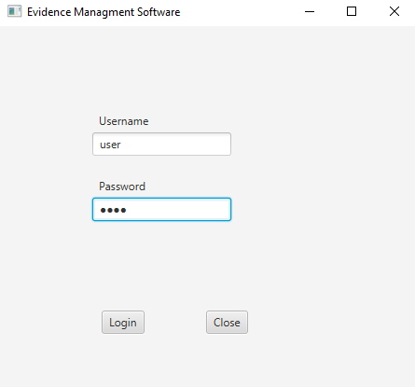

Important: If username or password is entered incorrectly, a user will not get access to the application.

# Accessing quick help.

To see quick help for using the program press F1.



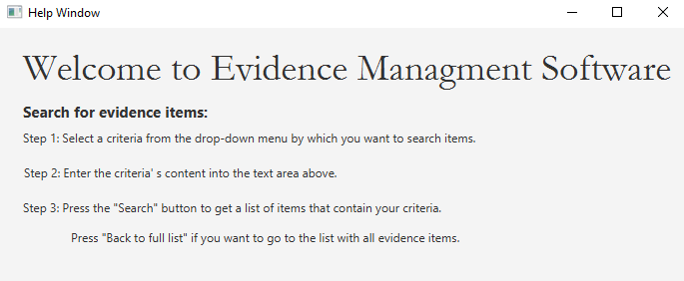

# Searching/viewing evidence data.

By default, list of evidence items is visible in a main view.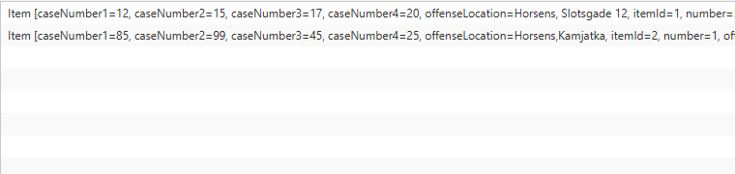

If you wish to see certain items, you need to follow these steps:

1.Select the criteria from drop-down menu by which you want to search items.

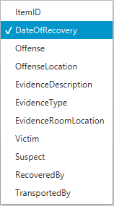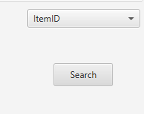

2.Enter criteria content into the field.

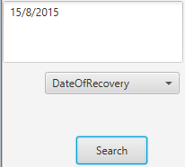

3.Press Search button

# Login as an administrator.

Enter username and password.

Note: by default, username and password has been created.

Username: ”admin”.

Password: “admin”.

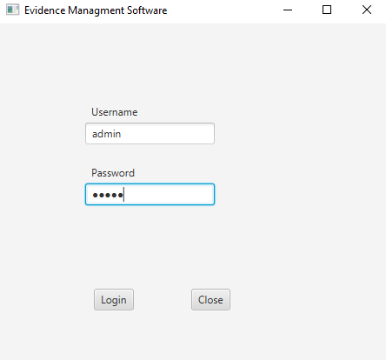

Important: If username or password is entered incorrectly, a user will not get access to the application.

# Searching/viewing evidence data as administrator.

See Searching/viewing evidence data.

# Adding new evidence data.

Note: only admin can access this feature of the system.

Press “Add” button.

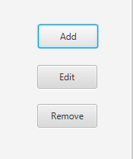

Fill out the fields in a pop-up window.

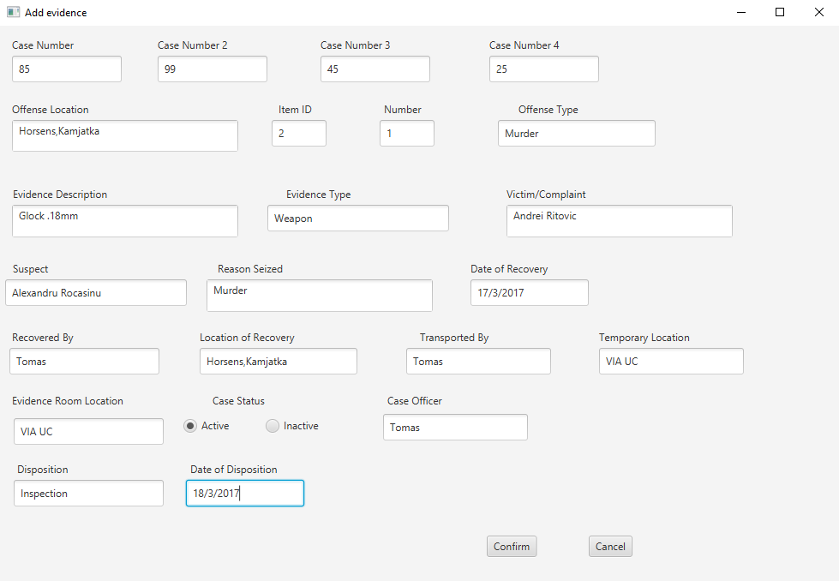

Press “Confirm” button.

If data you add is not valid (e.g case number has to be a number of digits) you will not be able to add an item. Date has to follow this format: dd/mm/yyyy.

# Editing existing evidence data.

Note: only admin can access this feature of the system.

Select an item from the list.



Press “Edit” button.

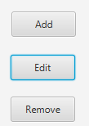

Edit the necessary fields in a pop-up window.

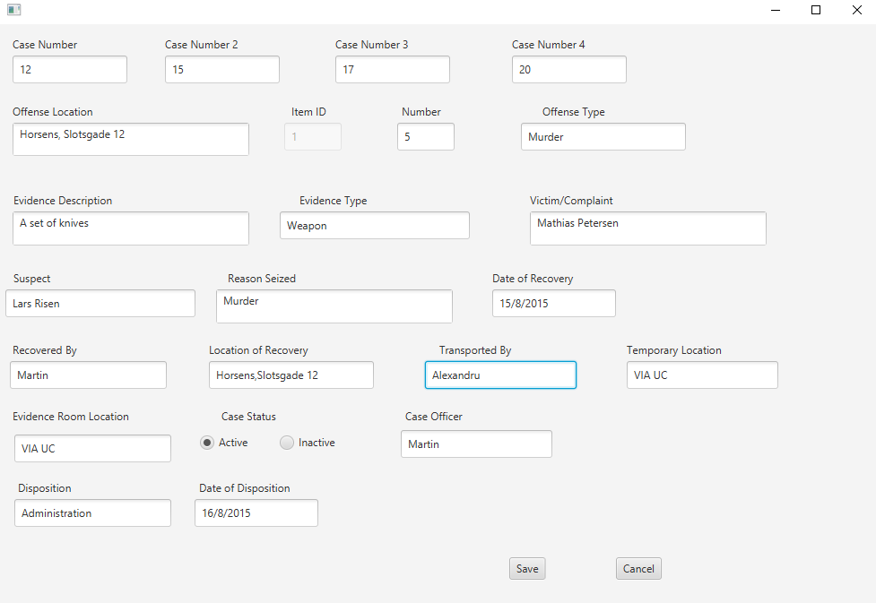

Press “Save” button.

# Removing existing evidence data.

Note: only admin can access this feature of the system.

Select an item from the list.



Press “Remove” button.

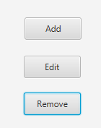

Confirm the removal by pressing “Ok” button.

